**Ciso services**

## DATE:08/17/2021

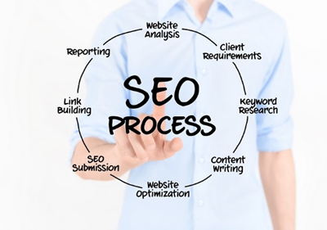

**THE SEO STRATEGY**

An effective SEO strategy will not only improve your SERP rankings but also enhance your presence of brand among the target market ultimately leading your business get qualifying leads organically. We will go with this project in a phase wise model that are as follows:

**Phase 1:**

In this phase, we will identify all of the major technical improvements required and fix them. These improvements may include:

* Meta tags, Title tags & descriptions, Heading tags etc.
* Page responsiveness that is basically the dev-side work. So, we can identify the problems and provide the solutions that your developers could work on to improve it.
* These improvements may include, reducing the CSS & JS files, reducing the size of images used on-page.
* Further we will identify any technical errors and improve them.
* Checking for XML sitemaps and Robot.txt file
* Ensuring canonical tags in your webpages
* Structured data markups analysis.

**Phase 2:**

This is the phase where we will be prepared to execute an effective on-page SEO strategy. The on-page SEO steps may include:

* Effective keyword research
* Trends research on particular regions where you provide services.
* Competitor’s analysis, to understand their strategy and keywords targeting.
* Website content analysis, improving your content and implementing effective CTAs to grab your audience.
* Web-pages optimization
* Submitting your site to Google search console for crawling and indexing.

**Phase 3:**

This is the point where we conduct research on backlinks analysis. We will identify the poor links that has been created for your website and the broken links to disavow them. Because such links can affect the performance of your website therefore, we will improve this at first priority. We will devise a backlink strategy for your webpages following the keywords that have been used. Number of backlinks that would be created are as follows:

* Article submission
* Blog posts submission
* Web 2.0
* Image submission
* Business listing. Etc.

**Expected Outcomes:**

* Improved SERP stats
* Particular keywords will start ranking based on their KGRs and within a month.
* Website will appear in the top results on Google’s first page within 2-3 months.
* Boost in targeted website traffic.
* After the website is ranked properly, 4-5 leads per week are expected.
* Further optimization can possibly be done to improve results and get maximum leads as SEO is the continuous process.